Project Design Phase-II

Data Flow Diagram & User Stories

|  |  |
| --- | --- |
| Date | 04 November 2022 |
| Project Name | Project - Smart Fashion Recommender Application |

**Fashion Recommender:**

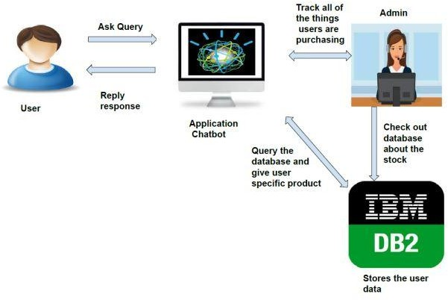

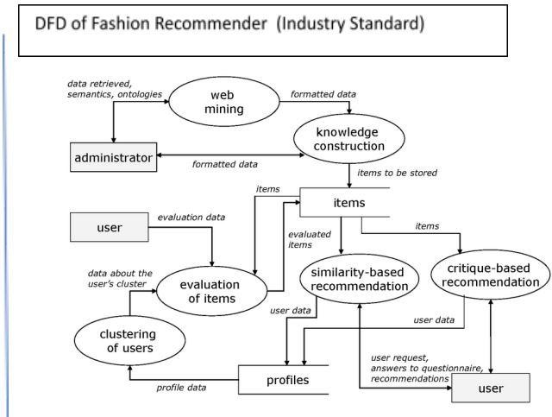

**User Stories**

|  |  |  |  |  |  |  |
| --- | --- | --- | --- | --- | --- | --- |
| **User Type** | **Functional** | **User** | **User Story / Task** | **Acceptance** | **Prio** | **Relea** |
|  | **Requirement** | **Stor** |  | **criteria** | **rity** | **se** |
|  | **(Epic)** | **y** |  |  |  |  |
|  |  | **Num** |  |  |  |  |
|  |  | **ber** |  |  |  |  |
| Customer (Mobile user) | Registration | USN-1 | As a user, I can register for the application by entering my email, password, and confirming my password. | I can access my account / dashboard | High | Sprint  -1 |
|  |  | USN-2 | As a user, I will receive | I can receive | High | Sprint |
|  | confirmation email once I | confirmation |  | -1 |
|  | have registered for the | email & click |  |  |
|  | application | confirm |  |  |
|  |  | USN-3 | As a user, I can register for | I can register & | Low | Sprint |
|  | the application through | access the |  | -2 |
|  | Email | dashboard with |  |  |
|  |  | Email |  |  |
|  |  | Login |  |  |

|  |  |  |  |  |  |  |
| --- | --- | --- | --- | --- | --- | --- |
|  |  | USN-4 | As a user, I can register for | I can register & | Medi | Sprint |
|  | the application through | access the | um | -1 |
|  | Gmail | dashboard with |  |  |
|  |  | Gmail |  |  |
|  |  | Login |  |  |
|  | Login | USN-5 | As a user, I can log into | I can login into | High | Sprint |
|  |  | the application by entering | the |  | -1 |
|  |  | my username/email & | applicatio |  |  |
|  |  | password | n with |  |  |
|  |  |  | Gmail |  |  |
|  |  |  | Login |  |  |
| Customer (Web user) | Dashboard  Registration | USN-5  USN-1 | As a user, I can log access the Dashboard of the application by logging into the application  As a user, I can register for the web-page by entering my email, password, and confirming my password. | I can access the Dashboard by logging into the application I can access my account / dashboard | High  High | Sprint  -1  Sprint  -1 |
|  |  | USN-2 | As a user, I will receive | I can receive | High | Sprint |
|  | confirmation email once I | confirmation |  | -1 |
|  | have registered for the | email & click |  |  |
|  | web-page | confirm |  |  |
|  |  | USN-3 | As a user, I can register | I can register & | Low | Sprint |
|  | for the web-page through | access the |  | -2 |
|  | Email | dashboard with |  |  |
|  |  | Email |  |  |
|  |  | Login |  |  |
|  |  | USN-4 | As a user, I can register | I can register & | Medi | Sprint |
|  | for the web-page through | access the | um | -1 |
|  | Gmail | dashboard with |  |  |
|  |  | Gmail |  |  |
|  |  | Login |  |  |
|  | Login | USN-5 | As a user, I can log into | I can login into | High | Sprint |
|  |  | the web-page by entering | the |  | -1 |
|  |  | my username/email & | applicatio |  |  |
|  |  | password | n with |  |  |
|  |  |  | Gmail |  |  |
|  |  |  | Login |  |  |

|  |  |  |  |  |  |  |
| --- | --- | --- | --- | --- | --- | --- |
| **User Type** | **Functional** | **User** | **User Story / Task** | **Acceptance** | **Priority** | **Releas** |
|  | **Requirem** | **Stor** |  | **criteria** |  | **e** |
|  | **ent** | **y** |  |  |  |  |
|  | **(Epic)** | **Num** |  |  |  |  |
|  |  | **ber** |  |  |  |  |

|  |  |  |  |  |  |  |
| --- | --- | --- | --- | --- | --- | --- |
|  | Dashboard | USN-5 | As a user, I can log | I can access the | High | Sprint- |
|  |  | access the Dashboard | Dashboard by |  | 1 |
|  |  | by logging into the | logging into the |  |  |
|  |  | web-page | web-page. |  |  |
| Customer | Login | USN-1 | As a Customer Care | I can login into the | High | Sprint- |
| Care |  |  | Executive, I can log | application |  | 1 |
| Executive |  |  | into the application by | with Gmail |  |  |
|  |  |  | entering my Executive | Login |  |  |
|  |  |  | email id & password |  |  |  |
|  | Dashboard | USN-1 | As a Customer Care | I can access the | High | Sprint- |
|  |  | Executive, I can | Dashboard by |  | 1 |
|  |  | access the | logging into the |  |  |
|  |  | Dashboard of the | application |  |  |
|  |  | application by logging |  |  |  |
|  |  | into the application |  |  |  |
|  | Service | USN-1 | As a Customer Care | I can access | High | Sprint- |
|  |  | Executive, I can | the Service |  | 1 |
|  |  | access the Customer | pageby logging |  |  |
|  |  | service page of the | & |  |  |
|  |  | application by logging | accessing the |  |  |
|  |  | and accessing the | page |  |  |
|  |  | page |  |  |  |
| Administrator | Login | USN-1 | As a Administrator, I can log into the  application by entering my Administer email id & password | I can login into the application  with Gmail Login | High | Sprint- 1 |